**DAILY ONLINE ACTIVITIES SUMMARY**

|  |  |  |  |  |  |  |  |  |
| --- | --- | --- | --- | --- | --- | --- | --- | --- |
| **Date:** | **22/05/2020** | | | | | **Name:** | **SPOORTI S DAROJI** | |
| **Sem & Sec** | **4th SEM. & ‘B’ SEC.** | | | | | **USN:** | **4AL18CS088** | |
| **Online Test Summary** | | | | | | | | |
| **Subject** | | **OPERATING SYSTEM** | | | | | | |
| **Max. Marks** | | **30** | | **Score** | | | **26** | |
| **Certification Course Summary** | | | | | | | | |
| **Course** | **Python for Machine Learning** | | | | | | | |
| **Certificate Provider** | | | **Greatlearning**  **academy** | | **Duration** | | | **5 Hrs.** |
| **Coding Challenges** | | | | | | | | |
| **Problem Statement 1:** [**Write a C Program to**](https://github.com/orgs/alvas-education-foundation/teams/2nd-year/discussions/67) **implement various operations on SLL**  **Hint: First Create a Singly Linked List Stack with the node corresponding to First Element is the base of the stack; and its link field must be always Null.**  **When you push First Element, It is the First and it is the Base of the stack. Its Link must be Null. top pointer pointing to First. (top = First)**  **When you push any element, (No need of checking Stack full case because SLL is dynamic) Create a new node called temp using malloc function and insert the a number into Data field, and Link field must be pointing to top; and move the pointer top to point to temp.**  **When you pop, First check for stack Empty. if First == NULL, then Stack Empty. If it is not empty, The pointer temp must be pointing to the top. Move the pointer top to top->link. delete temp.**  **When you display the stack element, First Check for Stack Empty as in pop operation. If it is not empty, Display all the elements of the current stack starting from top to First.**  **Problem Statement 2:Write a C or Java program to implement round robin type of process scheduling.**  **Input: Process with burst time, arrival time and specify the time quantum**  **Output: Processes scheduled based on the round robin type of scheduling, with its average waiting time.** | | | | | | | | |
| **Status: Executed.** | | | | | | | | |
| **Uploaded the report in Github** | | | | | **Yes** | | | |
| **If yes Repository name** | | | | | [alvas-education-foundation](https://github.com/alvas-education-foundation)/[spoorti_daroji](https://github.com/alvas-education-foundation/spoorti_daroji) | | | |
| **Uploaded the report in slack** | | | | | **Yes** | | | |

**Online Test Summary: 18CS43 test was scheduled from 9:15AM to 9:45AM.The Portion for the IA was 1st module there were 30 questions of one mark & the time assigned was 30 minutes. The questions were mcq type.**

**Online Certification course Summary: In today’s session I have learnt about Conditional Statements used in Python like if, else and elseif(elif) statements after that i came to know loops such as for loop,while loop,nested loops.**

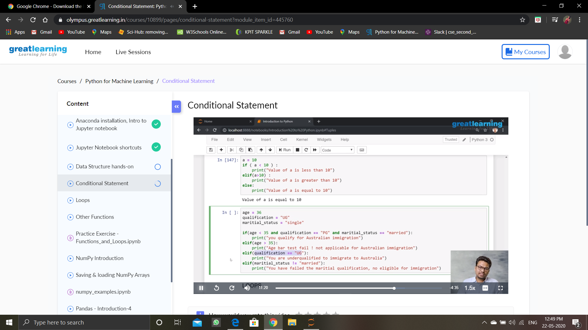

**I had gone through some examples where I learnt how they are used in python,using jupyter notebooks.As shown in the snapshot below.**

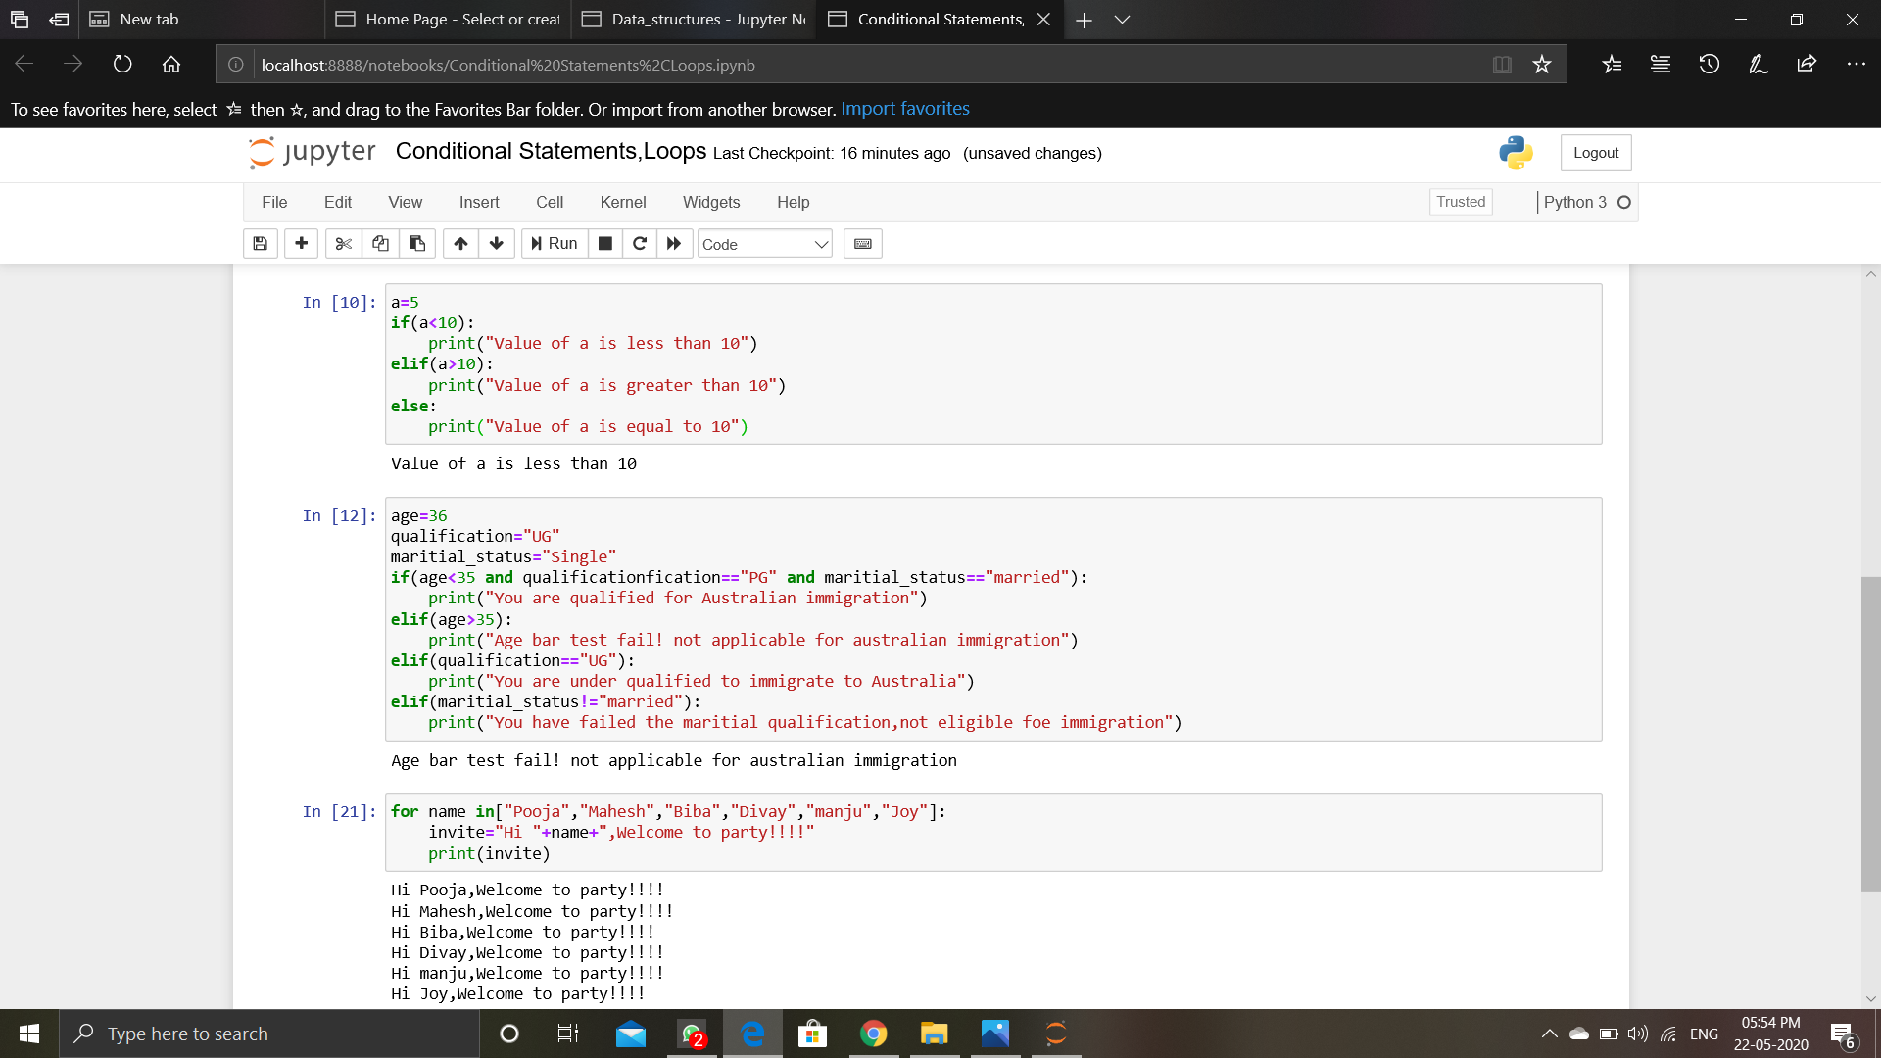**Online Coding Summary: Today I received the program from prof.Venkatesh CSE Dept, and another program was given by prof.Harshitha GM CSE Dept .**

**The programs are mentioned above in the coding challenges.I have written programs and uploaded it to my Github repository.**

**It is the snapshot of my repository were i have uploaded the code.file name is SLLOperations.c and robin.cpp**

